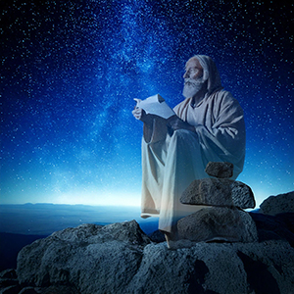 | Belief in Ghosts  The belief of an apparition of a dead person which is believed to appear or become manifest to the living.

1 Samuel 28: 13-14 The king said to her, “Don’t be afraid. What do you see?”
The woman said, “I see a ghostly figure coming up out of the earth.”
“What does he look like?” he asked. “An old man wearing a robe is coming up,” she said.
Then Saul knew it was Samuel, and he bowed down and prostrated himself with his face to the ground.

Mark 6: 21:45,25 Immediately Jesus made His disciples get into the boat and go ahead of Him to the other side to Bethsaida. But when they saw Him walking on the sea, they supposed that he was a ghost, and cried out

Luke 25:36-40 While they were telling these things, He Himself stood in their midst and said to them, “Peace be to you.” But they were startled and frightened and thought that they were seeing a ghost. And He said to them, “Why are you troubled, and why do doubts arise in your hearts? See My hands and My feet, that it is I Myself; touch Me and see, for a ghost does not have flesh and bones as you see that I have.” And when He had said this, He showed them His hands and His feet.

