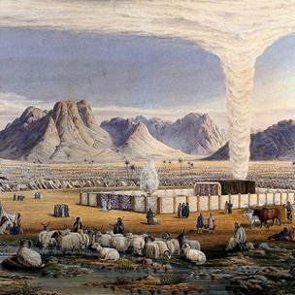 | Magick - Air  The science and art of causing change to occur in conformity with the will using the element of the air.

Exodus 13:20-22 After leaving Sukkoth they camped at Etham on the edge of the desert. By day the Lord went ahead of them in a pillar of cloud to guide them on their way and by night in a pillar of fire to give them light, so that they could travel by day or night. Neither the pillar of cloud by day nor the pillar of fire by night left its place in front of the people.

1 Kings 18:42-54 So Ahab went up to eat and drink. But Elijah went up to the top of Carmel; and he crouched down on the earth and put his face between his knees. He said to his servant, “Go up now, look toward the sea.” So he went up and looked and said, “There is nothing.” And he said, “Go back” seven times.

It came about at the seventh time, that he said, “Behold, a cloud as small as a man’s hand is coming up from the sea.”

And he said, “Go up, say to Ahab, ‘Prepare your chariot and go down, so that the heavy shower does not stop you.’”

In a little while the sky grew black with clouds and wind, and there was a heavy shower.

Matthew 8:23-27 Then he got into the boat and his disciples followed him. Suddenly a furious storm came up on the lake so that the waves swept over the boat.

But Jesus was sleeping. The disciples went and woke him, saying, “Lord, save us! We’re going to drown!” He replied, “You of little faith, why are you so afraid?”

Then he got up and rebuked the winds and the waves, and it was completely calm. The men were amazed and asked, “What kind of man is this? Even the winds and the waves obey him!”

