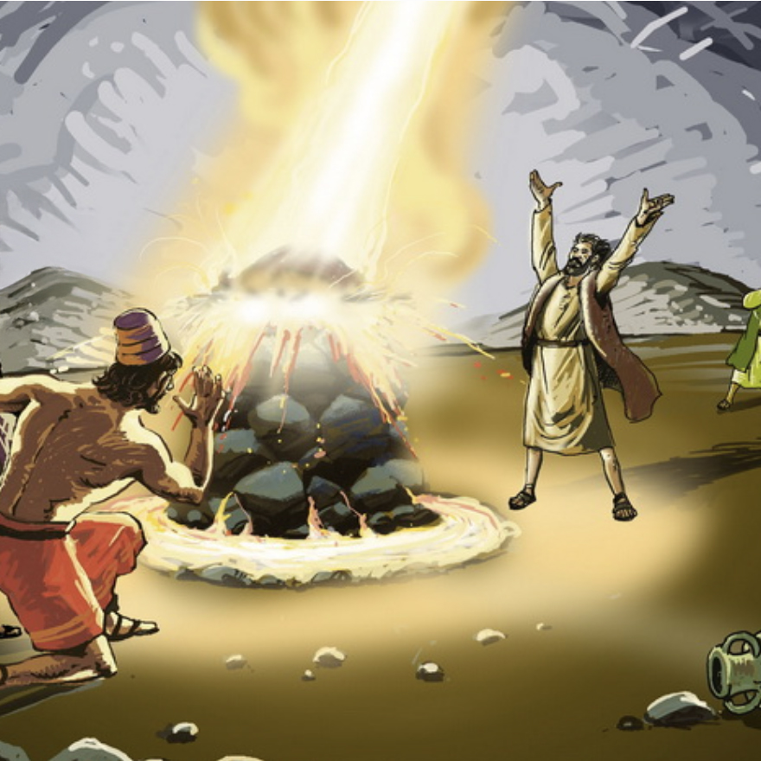 | Magick - Fire  The science and art of causing change to occur in conformity with the will using the element of fire.

Exodus 13:20-22 After leaving Sukkoth they camped at Etham on the edge of the desert. By day the Lord went ahead of them in a pillar of cloud to guide them on their way and by night in a pillar of fire to give them light, so that they could travel by day or night. Neither the pillar of cloud by day nor the pillar of fire by night left its place in front of the people.

Leviticus 9:20-24 Moses and Aaron then went into the tent of meeting. When they came out, they blessed the people; and the glory of the Lord appeared to all the people. Fire came out from the presence of the Lord and consumed the burnt offering and the fat portions on the altar. And when all the people saw it, they shouted for joy and fell facedown

Leviticus 10:1-2 Aaron’s sons Nadab and Abihu took their censers, put fire in them and added incense;and they offered unauthorized fire before the Lord, contrary to his command. So fire came out from the presence of the Lord and consumed them, and they died before the Lord.

Numbers 11:1-3 Now the people complained about their hardships in the hearing of the Lord, and when he heard them his anger was aroused. Then fire from the Lord burned among them and consumed some of the outskirts of the camp. When the people cried out to Moses, he prayed to the Lord and the fire died down. So that place was called Taberah, because fire from the Lord had burned among them.

1 kings 18:30-39 Then Elijah said to all the people, “Come here to me.” They came to him, and he repaired the altar of the Lord, which had been torn down. Elijah took twelve stones, one for each of the tribes descended from Jacob, to whom the word of the Lord had come, saying, “Your name shall be Israel.” With the stones he built an altar in the name of the Lord, and he dug a trench around it large enough to hold two seahs of seed. He arranged the wood, cut the bull into pieces and laid it on the wood. Then he said to them, “Fill four large jars with water and pour it on the offering and on the wood.”

“Do it again,” he said, and they did it again.

“Do it a third time,” he ordered, and they did it the third time. The water ran down around the altar and even filled the trench.

At the time of sacrifice, the prophet Elijah stepped forward and prayed: “Lord, the God of Abraham, Isaac and Israel, let it be known today that you are God in Israel and that I am your servant and have done all these things at your command. Answer me, Lord, answer me, so these people will know that you, Lord, are God, and that you are turning their hearts back again.”

Then the fire of the Lord fell and burned up the sacrifice, the wood, the stones and the soil, and also licked up the water in the trench.

When all the people saw this, they fell prostrate and cried, “The Lord—he is God! The Lord—he is God!”

2 kings 1:9-12 Then he sent to Elijah a captain with his company of fifty men. The captain went up to Elijah, who was sitting on the top of a hill, and said to him, “Man of God, the king says, ‘Come down!’”

Elijah answered the captain, “If I am a man of God, may fire come down from heaven and consume you and your fifty men!” Then fire fell from heaven and consumed the captain and his men.

At this the king sent to Elijah another captain with his fifty men. The captain said to him, “Man of God, this is what the king says, ‘Come down at once!’”

“If I am a man of God,” Elijah replied, “may fire come down from heaven and consume you and your fifty men!” Then the fire of God fell from heaven and consumed him and his fifty men.

Daniel 3:19-25 Then Nebuchadnezzar was furious with Shadrach, Meshach and Abednego, and his attitude toward them changed. He ordered the furnace heated seven times hotter than usual and commanded some of the strongest soldiers in his army to tie up Shadrach, Meshach and Abednego and throw them into the blazing furnace. So these men, wearing their robes, trousers, turbans and other clothes, were bound and thrown into the blazing furnace. The king’s command was so urgent and the furnace so hot that the flames of the fire killed the soldiers who took up Shadrach, Meshach and Abednego, and these three men, firmly tied, fell into the blazing furnace.

Then King Nebuchadnezzar leaped to his feet in amazement and asked his advisers, “Weren’t there three men that we tied up and threw into the fire?”
They replied, “Certainly, Your Majesty.”
He said, “Look! I see four men walking around in the fire, unbound and unharmed, and the fourth looks like a son of the gods.”

